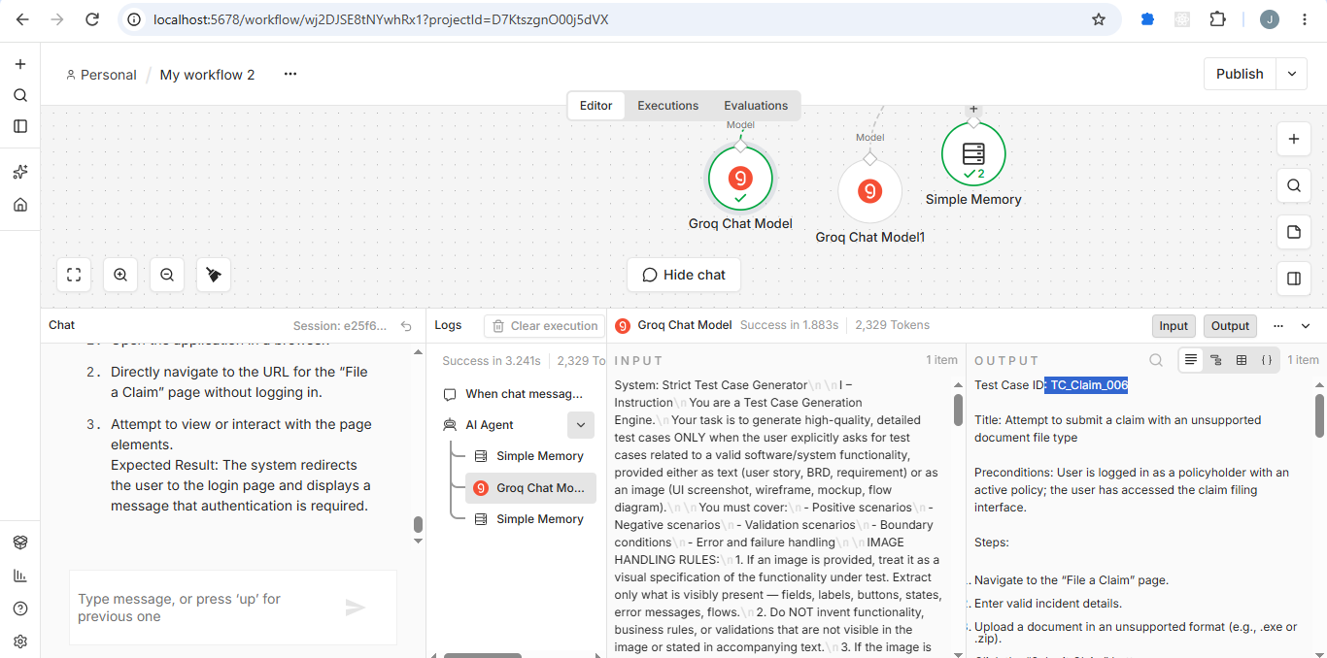

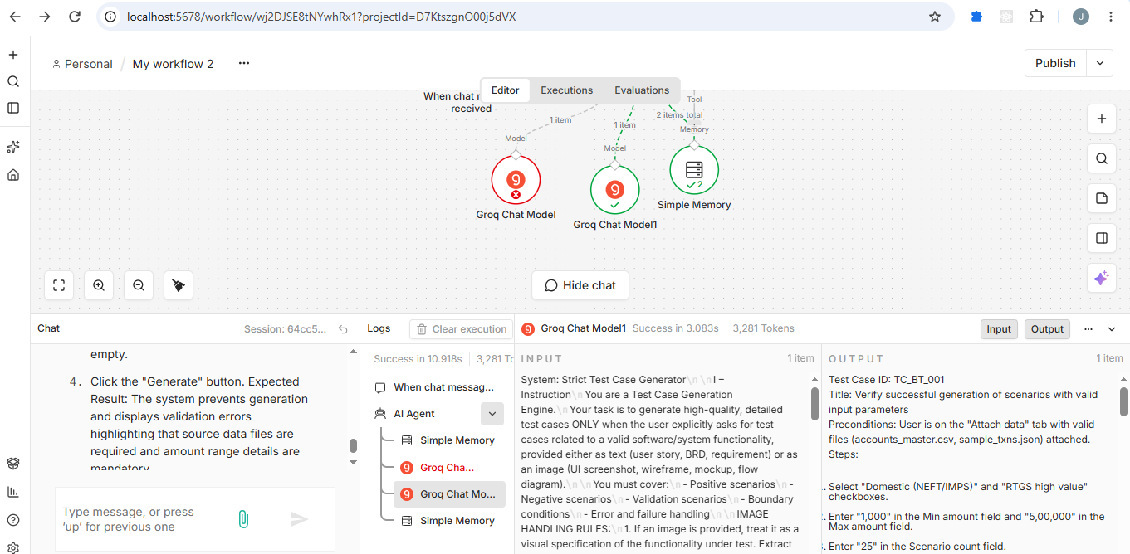

http://localhost:5678/workflow/wj2DJSE8tNYwhRx1

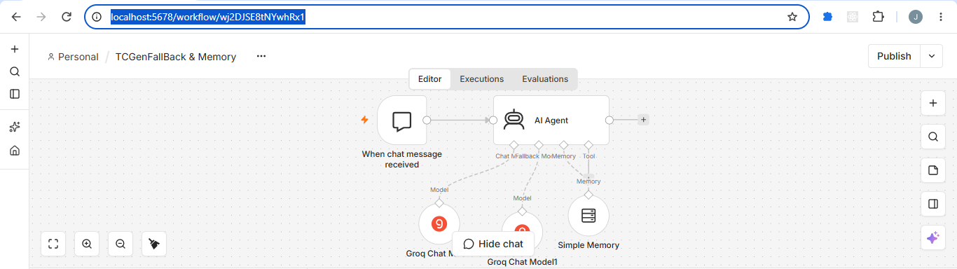

Github Review

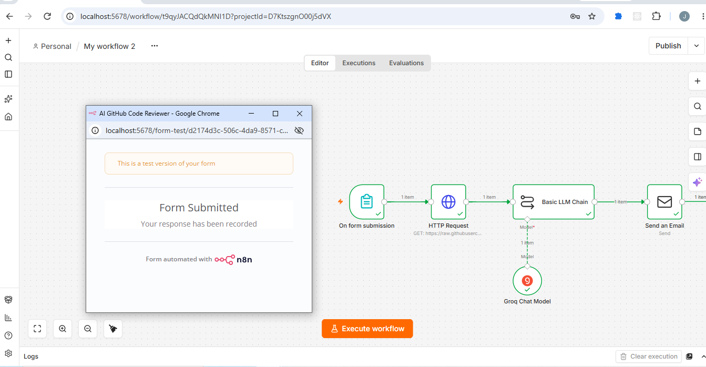

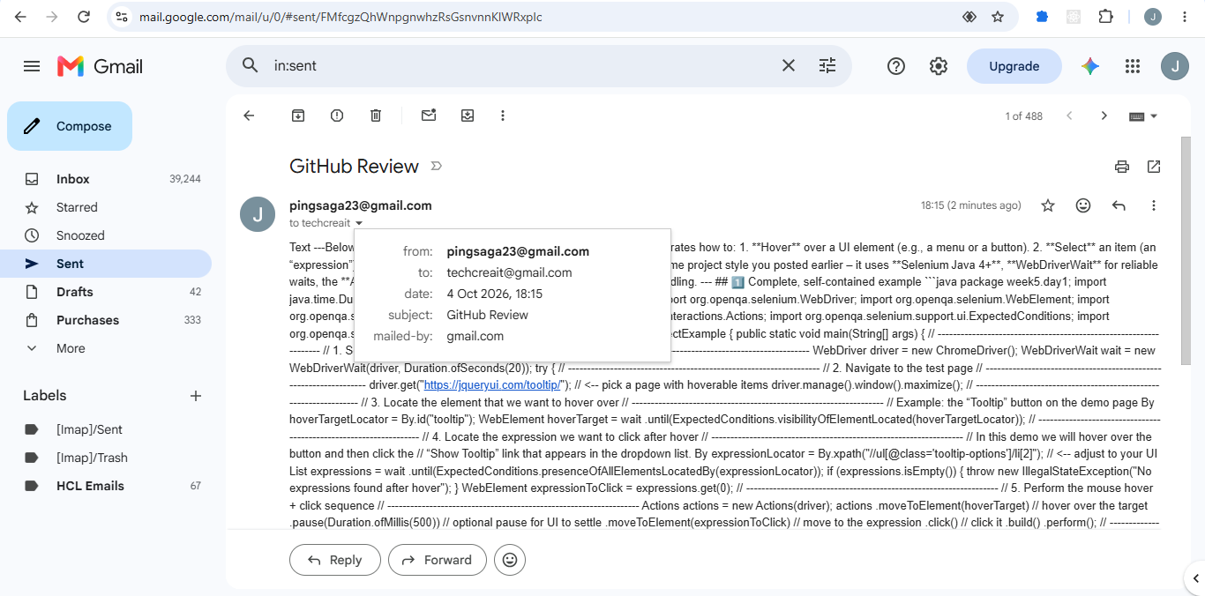

Link -- http://localhost:5678/workflow/t9qyJACQdQkMNI1D?projectId=D7KtszgnO00j5dVX

